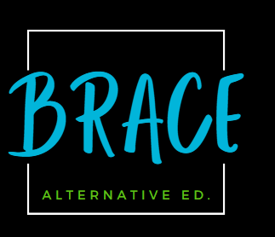

Battle River Alternative Centre for Education

Student Handbook

https://cos.brsd.ab.ca/

North Door
6205- 48 Ave
Camrose, AB T4V0K4
780-672-2205

Hours of Operation
Monday- Thursday 8:40 a.m. – 3:00 p.m.

Night School: Tues/Wednesdays
5:00pm -7:30pm

Friday- Closed
BRACE follows the BRSD Calendar for operational days.

Welcome to Battle River Alternative Centre for Education (BRACE)!
Thank you for choosing BRACE as the school to help you to meet your educational goals. We welcome full time students who choose to have BRACE as their primary high school as well as shared students who do most of their courses at another BRSD high school and use BRACE to facilitate courses they need flexibility in taking. We also welcome adult learners or students choosing to upgrade.

BRACE is a supportive, alternative senior high school for students who require a non-traditional, individualized program. Located in the senior high building in Camrose, BRACE provides students with:

- a safe, comfortable environment
- flexible, individual schedules with courses being offered online.
- the opportunity to take responsibility for their own education and to experience success.
- excellent teachers and encouraging and supportive staff.

Mission

To develop strong healthy relationships within flexible learning environment while assisting students in meeting their educational needs.

Vision: “To be willing is to be able”

Beliefs: At BRACE we strive for:

Belonging – We are all better together.
Relationships – Support each other and make connections with classmates.
Accepting – Be mindful and inclusive of others.
Caring – Show kindness and compassion to others.
Excellence – Focus on learning and being engaged in your work.

Student Responsibilities
- Ensure that the student’s conduct contributes to a welcoming, caring, respectful and safe learning environment that respects diversity and fosters a sense of belonging.
- Respect the rights of others in the school.
- Refrain from, report and not tolerate bullying or bullying behaviour.
- Comply with rules of the school and policies of the board.
- Co-operate and comply with staff requests.
- Check your BRSD email for communication and updates.
- Daily attendance is not mandated however we encourage students to meet weekly with their teachers and complete at least one assignment every week to stay on track.
- Using cell phone responsibly and limiting use in school.

Course Registration and Completion
- Students are required to meet with their teacher to go through how to access Moodle before starting their courses. Email communication is sent out providing additional information. Course registration is based on availability and priority.
- Students can access their course through Moodle and can monitor their achievement though PowerSchool.
- Teachers regularly communicate with students via email and phone calls. It is the student’s responsibility to communicate with their teachers if they cannot meet deadlines. Students should be checking their BRSD email regularly.
- Suggested timelines for assessments are given to students by their teachers at their course start and are listed in the course outline.
- Students needing flexibility with their suggested timelines are encouraged to meet with their teacher to discuss a plan to achieve success.
- Courses all have specified due dates that must be adhered to.
- Students who do not engage with course material and do not complete required assessments or do not access Moodle will be withdrawn from their courses.
- Shared students will register for BRACE courses through their home school and must complete a registration package (registration form and BRACE acknowledgement form).
Students are encouraged to attend or meet (virtually) with their teacher on a regular basis. School staff are available to support students in successfully completing their courses. All assessments and courses are to be completed in a semester.

Attendance
- Because all courses are offered online and students taking BRACE courses reside all over our division, there is not mandatory daily attendance. However, students are most successful when they stay in close contact with their teachers and it is highly recommended that students meet in person, virtually, or via email at least once a week to ensure success.
- Students who attend in person can choose which of the two learning spaces they’d like to work in. All students must sign in when they arrive.
- Some learning assessments must be completed in person (Ie. Diploma Exams, finals) or proctored via their home school.

Resources
- Textbooks are provided by BRACE. Required books will be discussed with the teacher at the orientation meeting and students will be able to sign books out with school staff after their course enrolment is complete. Shared students sign out textbooks at their home schools.
- Computer/Chromebook access is available at BRACE. Students requiring additional access to technology can discuss arrangements with administration.

Student Supports
The following school staff are available to support students in their learning journeys. BRACE staff are invested in supporting student well-being and academic achievement.
- Family School Liaison Worker
- Career Counsellor
- School Resource Officer
- School Staff: Principal, Teachers, Educational Assistant, BRSD Consultants
- AHS Addictions and Mental Health
- Community Organizations like Public Health, CAFL, Foundational Learning, etc.

Graduation
BRACE students work toward achieving an Alberta High School Diploma or a Certificate of High School Achievement. Students work with their Teachers/ Administrator to ensure they are completing the required courses. BRACE celebrates the achievements of our students at a Graduation Ceremony in June of each year.

Parent Council
BRACE values and welcomes parent participation. School Council provides the opportunity to meet school staff and fellow parents and provides an opportunity of offer feedback on matters associated with the school. Presently BRACE does not have a school council in place.
Please contact us to become involved or visit the school website for information about creating a Parent Council. We look forward to hearing from you!

School Staff:
Principal | Melanie Buckley | mbuckley@brsd.ab.ca
Admin Assistant | Laural Hoff | lhoff@brsd.ab.ca
Educational Assistant | Shannon Olson | solson@brsd.ab.ca
Teacher | Amanda Cardinal | acardinal@brsd.ab.ca
Teacher | Sonja Cummings | scumming@brsd.ab.ca
Teacher | Dianna Kroetch | dkroetch@brsd.ab.ca
Teacher | Jennifer Lindstrand | jelindstrand@brsd.ab.ca
Teacher | Donnelle Millang | dmillang@brsd.ab.ca
Teacher | Alex Price | aprice@brsd.ab.ca

School Contact Information
- We are located through the North doors of Ecole Camrose Composite High School. We have designated parking for BRACE students and visitors.
6205-48 Avenue Camrose, AB T4V 0K0
Phone (780)672-2205.

Courses :
Brace offers a full range of academics and electives that meet Alberta Education High School Diploma requirements:
English:
English Language Arts at the 30 level is a graduation requirement for all high school students.
At BRACE we offer all Dash 1 and Dash 2 and Dash 4 English courses.
Students can follow one of two course sequences (illustrated above). Although the content of the courses is similar, the depth of concept development, the sophistication of textual analysis, and the complexity of text creation are more rigorous in the Dash 1 sequence.
Generally, the "dash 1" (-1) stream is for students who are university bound. The "dash 2" (-2) stream, while still academic, is suited for students who need more assistance in the subject matter. After completing the 10-2, 20-2 and 30-2 stream, a student can move to the 30-1 course in the subject.

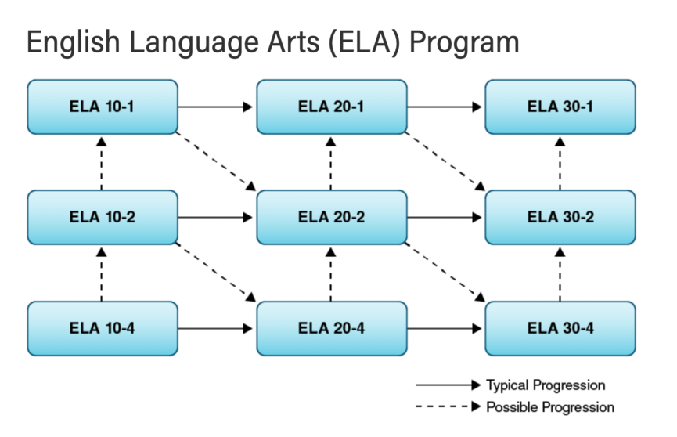
At BRACE we offer Math 10C, Dash 1, 2, and 3, and Math 31.
Alberta’s math program encourages students to develop mathematical reasoning and problem-solving skills and make connections between mathematics and its applications. Our program also builds students’ confidence in their mathematical skills and appreciation of the subject.
Alberta's math programs require that students can not only add, subtract, multiply and divide, but that they also know how to reason and solve problems in real-life situations.
Generally, the "dash 1" (-1) stream is for students who are university bound. The "dash 2" (-2) stream, while still academic, is suited for students who need more assistance in the subject matter. After completing the 10-2, 20-2 and 30-2 stream, a student can move to the 30-1 course in the subject.

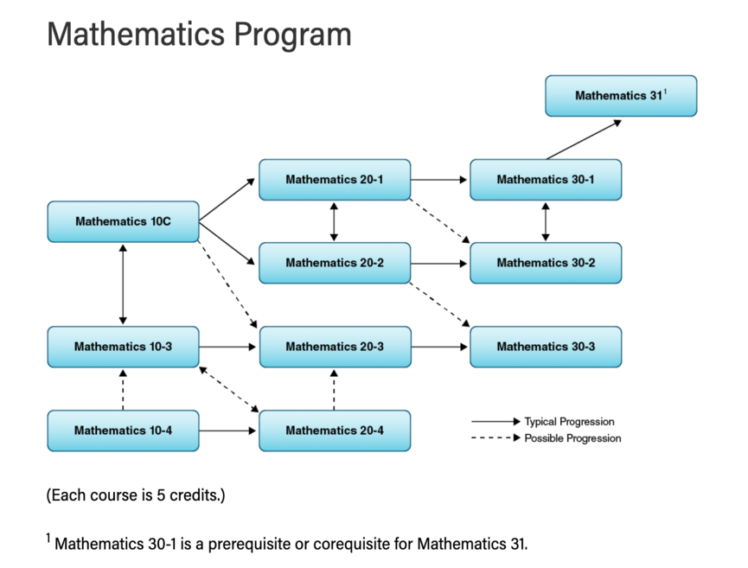

At BRACE we offer all sciences including Science 10, 14, 24, 20, and 30. We also offer Biology, Chemistry, and Physics.
Science (10-12) The secondary science program is guided by the vision that all students have the opportunity to develop scientific literacy.
Students will develop the science-related knowledge, skills and attitudes that they need to solve problems and make decisions, and at the same time help them become lifelong learners— maintaining their sense of wonder about the world around them.
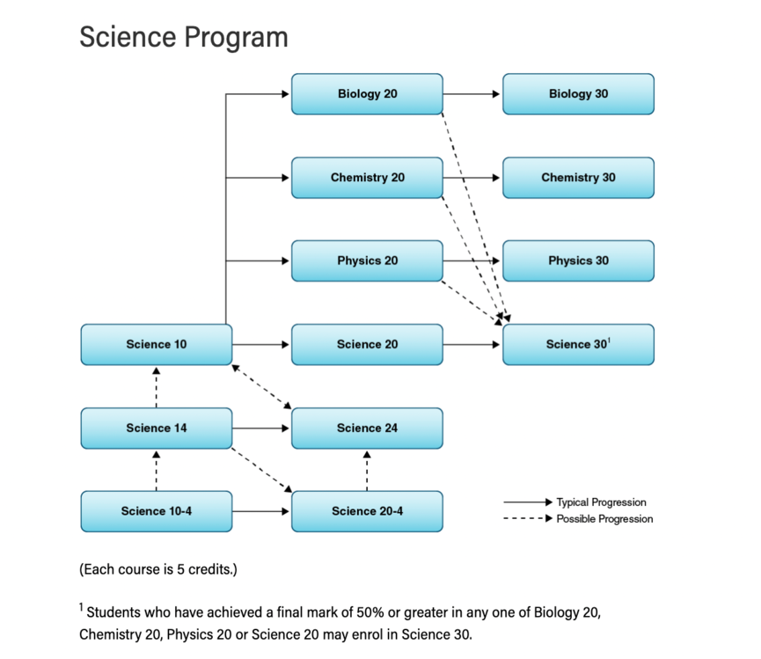

Social Studies at the 30 level is a requirement to graduate in Alberta.
At BRACE we offer social studies Dash 1 and 2.
Social Studies provides opportunities for students to develop the attitudes, skills and knowledge that will enable them to become engaged, active, informed and responsible citizens.
Recognition and respect for individual and collective identity is essential in a pluralistic and democratic society. Social studies helps students develop their sense of self and community, encouraging them to affirm their place as citizens in an inclusive, democratic society.
Generally, the "dash 1" (-1) stream is for students who are university bound. The "dash 2" (-2) stream, while still academic, is suited for students who need more assistance in the subject matter. After completing the 10-2, 20-2 and 30-2 stream, a student can move to the 30-1 course in the subject.

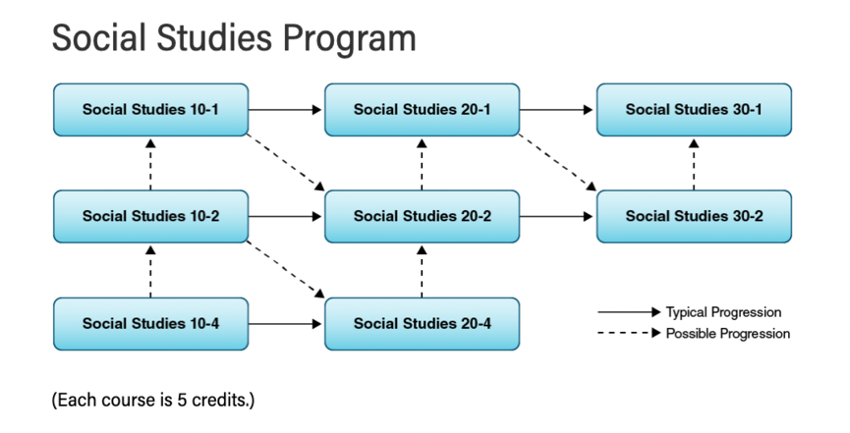

Elective Courses
At BRACE we offer a variety of options and CTS courses which vary from year to year based on student interest and teacher availability. For those wishing to graduate from BRACE we offer enough option choices to fulfill your high school graduation requirements.
Our website provides a course listing directory of choices available.

ALBERTA HIGH SCHOOL DIPLOMA: GRADUATION REQUIREMENTS (ENGLISH)
The requirements indicated below are the minimum requirements for a student to attain an Alberta High School Diploma. The requirements for entry into post-secondary institutions and workplaces may require additional and/or specific courses.
Please note - BRACE does not offer all of these courses. Please contact the school for more information.
